Guidelines for Oral Pre-Exposure Prophylaxis: TEMPLATE LANGUAGE FOR EVENT-DRIVEN PREP MODULE
The intent of this module is to provide adaptable guidelines for event-driven oral pre-exposure prophylaxis (ED-PrEP) that may be incorporated or added as an addendum to existing HIV oral PrEP guidelines. As with the parent document (Guidelines for Daily Oral Pre-Exposure Prophylaxis: TEMPLATE LANGUAGE (English/French)), the content here aligns with the oral PrEP guidance and recommendations of the World Health Organization (WHO). The document includes prompts for national-level consideration during the guideline adaptation process. Areas specifically requiring a national update are indicated in red font.
This document was developed by the Collaboration for HIV Prevention Options to Control the Epidemic (CHOICE) in close collaboration with the U.S. Agency for International Development (USAID). CHOICE is a collaboration between the USAID-funded Meeting Targets and Maintaining Epidemic Control (EpiC) and Reaching Impact, Saturation, and Epidemic Control (RISE) projects. The content of this document was sourced largely from the WHO Technical Brief – What’s the 2+1+1? Event-Driven Oral Pre-exposure Prophylaxis to Prevent HIV for Men Who Have Sex with Men: Updates to WHO’s Recommendation on Oral PrEP. Countries should use this module as appropriate for their needs and setting; use of CHOICE branding or acknowledgment is optional.

Table of Contents
Overview of Event-Driven Pre-Exposure Prophylaxis 1
Guidance for Offering ED-PrEP 1
ED-PrEP Effectiveness 2
Approved Drugs for ED-PrEP 2
Optimal ED-PrEP Service Delivery Package 2
ED-PrEP Initiation 2
Identifying Clients at Substantial Risk Who May Benefit from ED-PrEP Use 2
Contraindications for ED-PrEP 2
ED-PrEP Initiation Visit Schedule and Readiness Assessment 3
Follow-Up Visits for Clients Using ED-PrEP 3
Education and Counseling for ED-PrEP 4
Switching Between ED-PrEP and Daily PrEP 5
Management of ED-PrEP Clients in Specific Situations 6

Overview of Event-Driven Pre-Exposure Prophylaxis
Similar to daily oral pre-exposure prophylaxis (PrEP), event-driven oral PrEP (ED-PrEP), also called on-demand PrEP or 2+1+1, is effective in reducing the likelihood of acquiring HIV infection for men who have sex with men (MSM). The level of protection provided by ED-PrEP was strongly correlated with proper adherence, meaning it is important for clients to take the medication as prescribed and avoid missing any doses. Although daily PrEP involves taking medication throughout an undefined period of risk, which may be indefinite, ED-PrEP is the taking of PrEP for a period that is as short as three days and timed to correspond with anticipated sex. ED-PrEP use is only approved for MSM.

For consideration: National guidelines should determine which term for ED-PrEP, also called on-demand PrEP or 2+1+1, will be used in the guidance documents and consistently use this terminology throughout implementation. The World Health Organization (WHO) uses ED-PrEP, which is the term you will see throughout this module.

Guidance for Offering ED-PrEP
PrEP may be offered as a daily regimen or as an ED regimen for men who wish to prevent HIV acquisition through sex with other men. ED-PrEP may be appropriate for MSM who find it more effective and convenient, have infrequent sex (for example, less than two times per week on average), and are able to plan for sex at least two hours in advance, or who can delay sex for at least two hours.

ED-PrEP is not appropriate for women (cisgender or transgender), transgender men who have vaginal/frontal sex, men who have vaginal and/or anal sex with women, or people with chronic hepatitis B infection.

MSM should have an option to decide which regimen works for them. ED-PrEP should not be the only option for MSM.

ED regimen: Start ED-PrEP with a loading dose of two pills taken 2–24 hours before having sex to ensure sufficient drug levels to provide protection. Continue taking one pill of PrEP at the same time as the loading dose daily until two days after the last potential exposure. See Figures 1, 2, and 3 for examples of ED-PrEP dosing that correspond to different exposure scenarios. This process should be repeated for each period of potential exposure to HIV.

Figure 1: Example of ED-PrEP use for sex one time or in one day
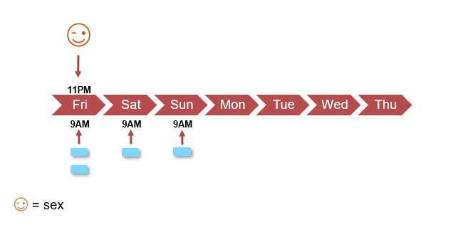

Figure 2: Example of ED-PrEP use for sex on multiple consecutive days
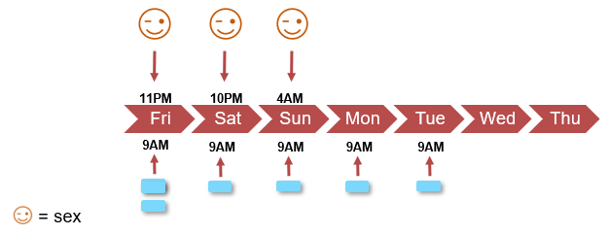

Figure 3: Example of ED-PrEP use for sex on multiple non-consecutive days
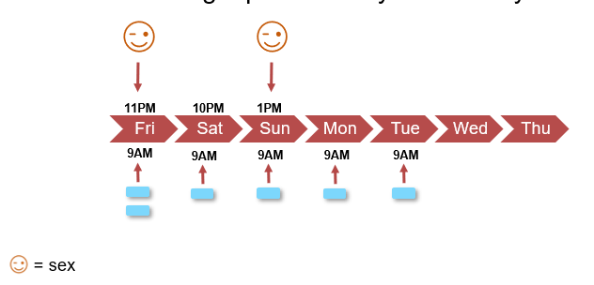
ED-PrEP Effectiveness
Similar to daily oral PrEP, ED-PrEP can reduce HIV acquisition through sexual transmission among MSM by more than 90% when taken as prescribed. ED-PrEP combined with other HIV prevention strategies, such as condom and lubricant use, harm reduction and treatment for drug use, reduction in number of sexual partners, and effective antiretroviral treatment for partners living with HIV, as applicable, can further reduce the likelihood of HIV acquisition among MSM.
Approved Drugs for ED-PrEP
In [country], either Tenofovir Disoproxil Fumarate/Emtricitabine (TDF/FTC) or TDF/Lamivudine (3TC) can be used for ED-PrEP for MSM. The WHO does not recommend use of TDF monotherapy and Emtricitabine and Tenofovir Alafenamide (FTAF) (brand name Descovy) for ED-PrEP.
Optimal ED-PrEP Service Delivery Package
The service package for MSM prescribed ED-PrEP is the same as that for those prescribed daily PrEP.
ED-PrEP Initiation
Identifying Clients at Substantial Risk Who May Benefit from ED-PrEP Use
For MSM, after behavior-based indications for oral PrEP have been established (including clients requesting PrEP without further explanation), the choice between taking daily PrEP or ED-PrEP depends upon the frequency and predictability of sex, as well as the client’s preferences. ED-PrEP may be more appropriate for MSM who find it more effective and convenient, have infrequent sex (for example, less than two times per week on average), and are able to plan for sex at least two hours in advance, or who can delay sex for at least two hours. MSM may also wish to transition between daily and ED-PrEP use at different times. Page 5 provides more information about switching between daily PrEP and ED-PrEP.
Contraindications for ED-PrEP
For ED-PrEP, all of the contraindications to daily PrEP apply. In addition, chronic hepatitis B in MSM is a contraindication to ED-PrEP, though MSM with chronic hepatitis B may be candidates for daily oral PrEP (if otherwise clinically eligible). Note that ED-PrEP is not appropriate for women (cisgender or transgender), transgender men who have vaginal/frontal sex, and men who have vaginal and/or anal sex with women.
ED-PrEP Initiation Visit Schedule and Readiness Assessment
Similar to daily PrEP, ED-PrEP can be initiated the same day for most clients. PrEP providers and clients should determine together whether daily PrEP or ED-PrEP may be appropriate by discussing the frequency and predictability of sex and asking about dosing preferences. Initiation visit steps for MSM prescribed ED-PrEP are the same as those for MSM starting daily PrEP with a few additional components outlined below in Table 1.

Table 1. Additional components of initiation visits for ED-PrEP
Additional Components | Action
Education and counseling | See page 4 for key education and counseling messages related to ED-PrEP initiation and effective use.
Hepatitis B surface antigen (HBsAg) | For consideration: The WHO does not explicitly require testing for hepatitis B for ED-PrEP users at initiation, although chronic hepatitis B is a contraindication for taking ED-PrEP. Countries should consider requiring hepatitis B screening for MSM taking ED-PrEP or transitioning from daily PrEP to ED-PrEP. Countries should also consider potential cost savings, which may be associated with hepatitis B vaccination compared to any retesting regimen.
Follow-Up Visits for Clients Using ED-PrEP
Similar to clients taking daily oral PrEP, it is recommended that once on ED-PrEP, MSM return after one month to assess and confirm HIV-negative test status, assess for early side effects, discuss any difficulties with medication adherence, and talk over any other client concerns. After the one-month follow-up visit, clients may return for follow-up visits every three months while they continue using ED-PrEP. The suggested return for follow-up every three months applies to MSM taking daily PrEP or ED-PrEP, since HIV testing needs to be completed during these quarterly return visits, even if additional PrEP is not dispensed.

Procedures at follow-up visits for MSM prescribed ED-PrEP are the same as those for MSM taking daily PrEP with minor modifications to the components outlined below in Table 2.

Table 2: Additional components of follow-up visits for ED-PrEP
Additional Components | Action
Education and counseling | See page 4 for key education and counseling messages related to ED-PrEP follow-up.
Hepatitis B surface antigen (HBsAg) | For consideration: Although WHO does not explicitly require testing for hepatitis B for ED-PrEP users during follow-up visits, chronic hepatitis B is a contraindication for taking ED-PrEP. Countries should consider requiring hepatitis B screening for MSM taking ED-PrEP or transitioning from daily PrEP to ED-PrEP at follow-up visits. Countries should also consider potential cost savings, which may be associated with hepatitis B vaccination compared to any retesting regimen.

Education and Counseling for ED-PrEP
Counseling about adherence for those on ED-PrEP may require additional time, given that habitual daily use is not the goal and effective use requires coordination of timing with sex. For some clients seemingly suited to ED-PrEP dosing, daily dosing may be more appropriate for reasons of personal preference including those related to anticipated ease of adherence. Adolescent MSM also may prefer or be better suited to daily PrEP rather than ED-PrEP use, even if they report infrequent and predictable sex. Table 3 outlines key education and counseling messages specific to ED-PrEP. These are in addition to messages about daily PrEP that should be covered with a client.

Table 3. Additional education and counseling messages for ED-PrEP clients
Topic | Key Messages
Risk reduction | Similar to daily PrEP, ED-PrEP does not reduce your risk of other sexually transmitted infections, so ongoing condom and lubricant use to prevent these is optimal. To be effective, the loading dose of two pills should be taken 2–24 hours before sex. If sex occurs less than two hours after taking the loading dose, other HIV prevention methods, such as condoms and lubricant, are needed to reduce the likelihood of HIV acquisition.
ED-PrEP works if taken as prescribed | For ED-PrEP to be effective, PrEP should be taken as prescribed.
Starting and stopping ED-PrEP | Two pills of PrEP must be taken 2–24 hours before having sex to have maximum efficacy. One pill of PrEP should be taken daily at the same time as the loading dose until two days after last potential exposure. This process should be repeated for each period of potential exposure to HIV.  Note to providers: When counseling clients on starting and stopping ED-PrEP, clients may benefit from job aids with visual representations of how doses should be taken over time in different scenarios.
Stopping ED-PrEP use | If a client wishes to indefinitely/permanently discontinue (meaning does not intend to resume ED-PrEP before future sex), nothing further is required. As long as the client takes one pill each day for two days after the last potential exposure, then the client can stop PrEP use. In the future, after not using PrEP as an HIV prevention method to reduce the risk of acquiring HIV during sex, the client can decide to restart PrEP (ED or daily), but should consult with a PrEP provider.
Sex less than two hours after loading dose or missed loading dose | If sex occurs less than two hours after taking the loading dose or the loading dose is missed, other HIV prevention methods, such as condoms and lubricant, are needed to reduce the likelihood of HIV acquisition.  If a client has sex without a condom less than two hours after taking the loading dose or after missing the loading dose, the client may be a candidate for a 28-day course of post exposure prophylaxis (PEP) per national guidelines.
Missed ED-PrEP dose(s) | For consideration:  WHO does not give guidance on what to do if someone misses a dose of ED-PrEP. Clients who miss an ED-PrEP dose(s) may be a candidate for a 28-day course of PEP per national guidelines. Because the timing and type of the sexual risk event will vary for each client in relation to the timing of the missed dose(s), such cases will require individual adjudication and a best clinical judgment.
Switching between ED-PrEP and daily PrEP | Since the frequency and predictability of sex may vary over time, the best PrEP dosing option for a client may change repeatedly. See details below in the section on Switching Between ED-PrEP and Daily PrEP.

Switching Between ED-PrEP and Daily PrEP
MSM may switch between ED-PrEP and daily PrEP due to changes in relationship status or sex partner(s) or moving to a new location, whereby the frequency and predictability of sex changes, or when a client’s preferred dosing option changes.

For clients who are taking ED-PrEP, transitioning to daily dosing may be appropriate if sex becomes more frequent and less predictable. To transition, a client should continue daily dosing indefinitely after the last exposure. Daily dosing would continue until sex becomes less frequent or more predictable again, or for as long as the client prefers the daily dosing option.

Figure 4: Example of transitioning from ED-PrEP to daily PrEP
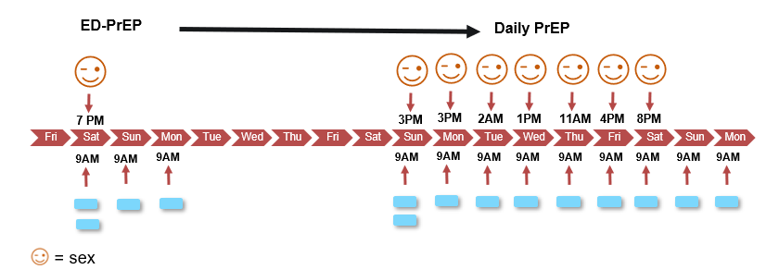

For clients who are taking daily PrEP, transitioning to ED-PrEP may be appropriate if sex becomes less frequent and more predictable and if the client does not have chronic hepatitis B. To transition, a client should stop daily dosing two days after last potential exposure then start following the ED-PrEP regimen until sex becomes more frequent or less predictable. See Figure 5 below.

Figure 5: Example of transitioning from daily PrEP to ED-PrEP
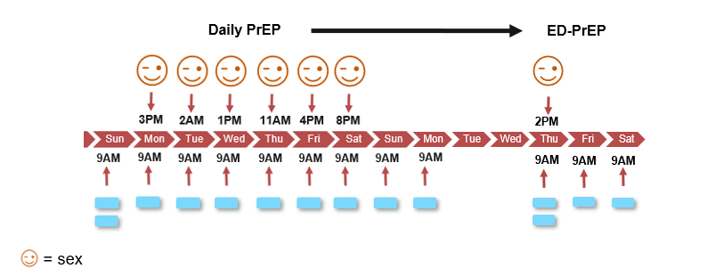
Management of ED-PrEP Clients in Specific Situations
For management of creatinine elevation, HIV seroconversion, and side effects and adverse drug reactions, refer to national guidelines for daily PrEP.
For consideration: If national guidelines do not address management of creatinine elevation, HIV seroconversion, and side effects and adverse drug reactions, consider including a section on this which can be found in the Guidelines for Daily Oral Pre-Exposure Prophylaxis: TEMPLATE LANGUAGE.

WHO. 2019. What’s the 2+1+1? Event-driven oral pre-exposure prophylaxis to prevent HIV for men who have sex with men: Update to WHO’s recommendation on oral PrEP. Technical brief. Available at: https://www.who.int/hiv/pub/prep/211/en/.

